.
Yohana Winiston Nungula attending the Scientific sessions at walter E.Washington convention center on July 18, 2025, during AVMA convention in Washington D.C

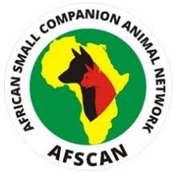

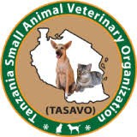

AFRICAN SMALL COMPANION ANIMAL NETWORK (AFSCAN) SCHOLARSHIP TO PHYSICALLY ATTEND AMERICAN VETERINARY MEDICAL ASSOCIATION (AVMA) AND WORLD VETERINARY ASSOCIATION (WVA) CONVETION IN WASHINGTON D.C., AND AVMA-AFSCAN GENERAL ASSEMBLY FROM JULY 18 TO JULY 22, 2025

Beneficiary/Attendee: Yohana Winiston Nungula
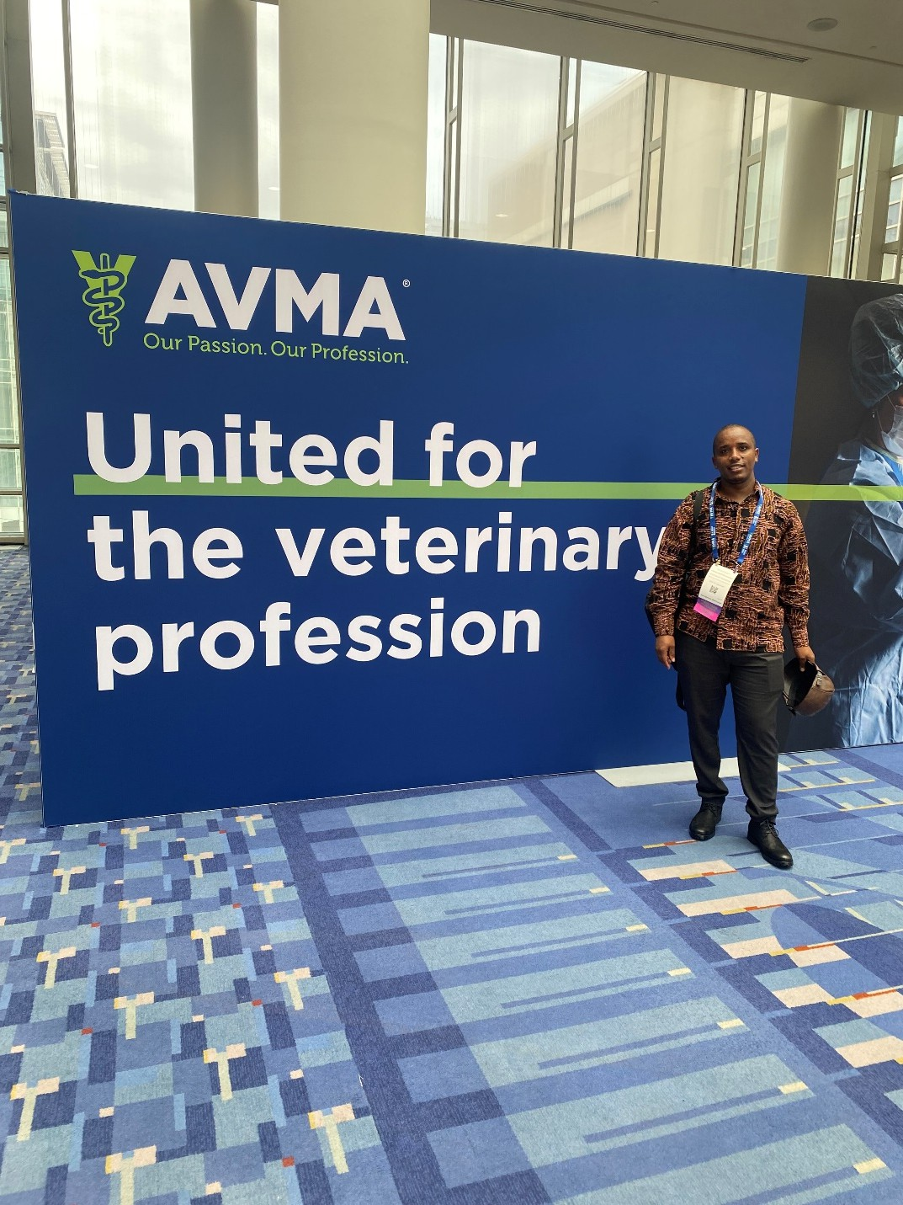

Executive summary
This article highlights my participation in the AVMA and WVA Convention held in Washington D.C., made possible through the AFSCAN scholarship. It outlines my engagement in scientific sessions, the AFSCAN General Assembly, professional networking opportunities, and the impact of this global veterinary collaboration on my professional development and contributions to veterinary medicine in Tanzania.

Introduction
The African Small Companion Animal Network (AFSCAN) is dedicated to improving and expanding veterinary services and building the capacity of veterinarians in Africa, veterinary practices in Africa, diseases control i.e., rabies, and connecting veterinarians in Africa, the United States of America (USA), and the United Kingdom (UK) through collaborations with member organizations in 10 English-speaking countries and two Portuguese-speaking countries in Africa.
To accomplish the aforementioned, AFSCAN has many initiatives; among them are AFSCAN scholarships, AFSCAN research awards, and AFSCAN virtual professional twinning meetings with the following groups:
- First, i.e., original AVMA-AFSCAN group, late 2018 launch from Dove Lewis USA-Kenya-Namibia, headed up by Dr. Sonja Zabel, Dr. Shana, O’Marra, and Ladan Mhamed-Zadeh, with six veterinarians from Namibia and Kenya.
- Second, AVMA-AFSCAN group Caring Hands (USA) and Nigeria, started as three clinic pairs between Caring Hands Clinics in Virginia, USA and Nigeria (early 2019 launch), headed by Olatunji Nassir in Nigeria.
- Third, British Small Animal Veterinary Association (BSAVA)-Zambia-Tanzania group, which launched in 2019, headed up by Drs. Mark Johnson and Julian Hoad from the UK.
- USA-Tanzania group, launched 2023/2024, headed by Dr. Kelly White, and approximately 45 veterinarians are part of the new growing group.
- Lastly, USA-Uganda/Burundi/Ghana/Ethiopia group, launched 2023, headed up by Dr. Francis Forman in the USA, currently at Dove Lewis, with others there interested in participating. Approximately 13 veterinarians participate.
Virtual twinning meetings are always followed by face-to-face meetings, whereby the AFSCAN Board offers scholarships to those actively participating in AFSCAN activities including twinning meetings and quarterly meetings.

This time I am very grateful for the great opportunity I got to attend the AVMA-WVA Conventions in Washington D.C., a convention attended by more than 7,800 participants—veterinarians and experts in veterinary medicine from all over the world.
As a first-time attendee and international participant, it was a very special experience for me to meet many veterinarians in the USA, discuss different important topics from experiences in the USA, the veterinary field in Tanzania and Africa, possible areas of collaboration and shared interests, attending well-organized parallel scientific sessions, the AVMA and AFSCAN General Assembly, WVA General Assembly, and social events in Washington D.C. After the meeting, I experienced small animal practice at the Veterinary Referral Associates in Maryland , where I shadowed for two full days.

2. AVMA Convention
The AVMA Convention started from July 18 to July 22, 2025, under the theme "United for the Veterinary Community", and involved the World Veterinary Association (WVA), bringing together veterinary professionals from around the world to collaborate, share knowledge, and address global challenges in animal health and public well-being.
The convention provided the opportunity for me to connect with veterinarians from diverse global backgrounds, share areas of mutual interest, and foster cooperation. There were over 700 hours of Continuing Education (CE) sessions, with over 600 sessions spanning clinical innovations, public health, food animal medicines, and professional wellness. A portion of sessions is accessible on-demand through December 31, 2025, in the convention mobile app.
The knowledge, skills, and techniques gained from the convention will help me to improve our practice and organization, and I will do inductions on different platforms and share reading materials. In this big convention, I was able to attend 26 hours of Continuing Education covering different topics. Click the link below for AVMA Proceedings reading materials.

Keynote Speakers and Award ceremony
The key speaker at the American Veterinary Medical Association (AVMA) Convention 2025,Meagan Leavey a former Marike K9 handler shared the inspirational story of her work with military working dog Rex, the focus was on strong bond between humans and animals and Leavy’s journey into veterinary fields after her service.
Professor Susan Mbugua was awarded Winners price as Veterinarian of the year for her excellent in trainings Veterinarians and practice by the World Veterinary Associations.

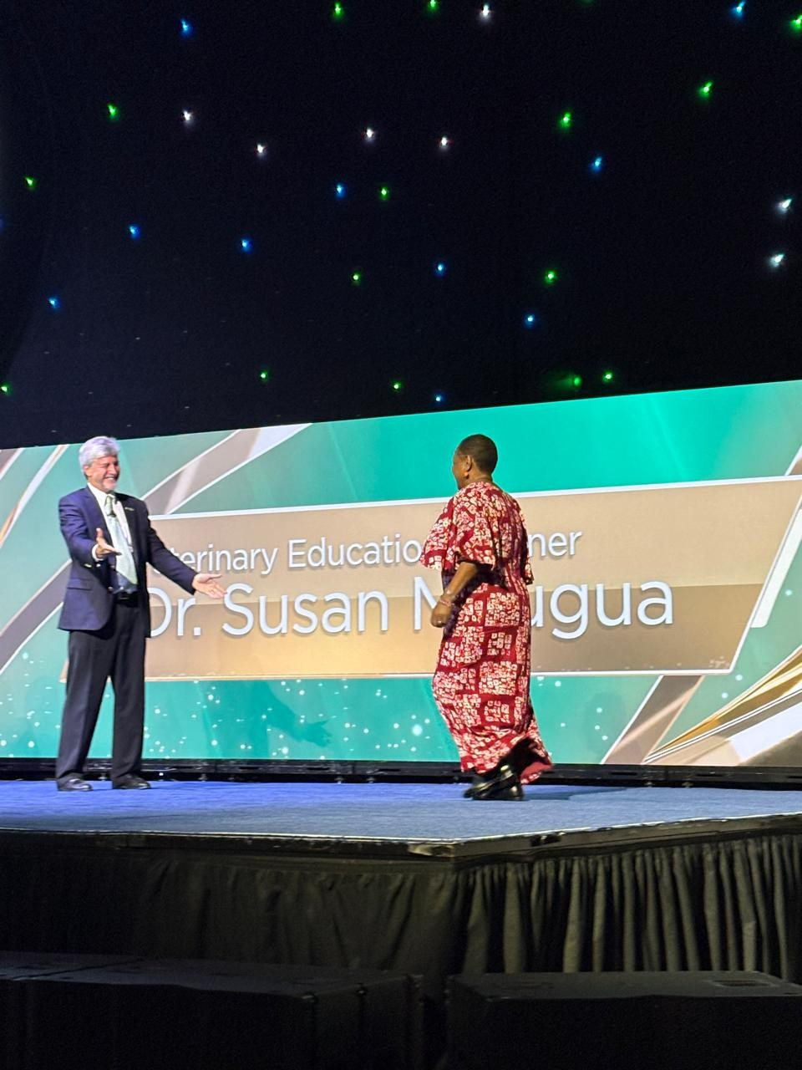

Prof.Susan Mbugua was warmly welcomed to the stage by the President of World Veterinary Associations (WVA) during awards ceremony at the Walter E.Washington Convention centre, She was honored with prestigious awards: Veterinarian of the year ward. July 20, 2025.

Exhibitions
I had the opportunity to visit a large exhibition event where I met different organizations, universities, veterinary drugs, equipment, and tools manufacturing companies. I was introduced, connected, and exchanged contacts.
In the exhibitions, there were different opportunities—i.e., internships, scholarships, management applications, and systems in veterinary practice. I learned and raised awareness on different new products, innovations, and technology which aid in improving veterinary service delivery.

AVMA-AFSCAN MEETING
AVMA-AFSCAN held on July 19, 2025 from 1pm Washington time. The meeting was hosted and led by Dr.Beth Sabin, Director, Global outreach Division, AVMA and Dr.Kevin Stevens AFSCAN board member. Attended physically by

AFSCAN Board Members and Host:
- Dr. Gabriel Varga, AFSCAN/ProSalus Foundation President
- Dr. Kevin Stevens, AFSCAN Board Member
- Dr. Michael Topper
- Dr.Rafael F.C Vieira

American Veterinary Medical Association Members Hosting Twinning Meetings:
- Dr. Shana O’marra
- Dr. Sonja Zabel AFSCAN Ambassadors
  - Prof.Susan Mbugua
  - Dr.Yohana Winiston Nungula
  - Dr.Samuel Derso Tezera
  - Dr.Olantunji Nasir

  - Dr.Bala Mohammad
Ambassadors and Veterinarians attended virtually
  - Dr.Brian Neuman
  - Dr.Alex Marko, AFSCAN board member and Ambassador
  - Dr.Lilian Wanjiku Mathai
  - Dr.Alex Chang’a
  - Dr.Aashna Mamlani,,
  - Dr.Chistina Oliveira, AFSCAN board member
  - Dr.Koney
The following were the resolutions from the assembly:
Members introduced themselves and reported the progress of the twinning meetings in their respective countries and member organizations. I, Yohana Winiston Nungula, and Samuel Tereza introduced ourselves and explained the important opportunity of the AFSCAN Scholarship to AVMA and WVA, which allowed us to represent our organizations, learn, experience, and build networks with other veterinarians from the USA and the globe.
- Improving and expanding twinning meetings—both group twinnings and individual twinnings—by inviting more veterinary practitioners to join the twinning and discuss clinical cases both in formal meetings and in other platforms, i.e., WhatsApp.
- Veterinarians in Africa to be flexible in setting the time of the twinning meetings in agreement with the experts who are the hosts of the twinning meetings.
- Ambassadors to prepare good quarterly reports from their organizations and submit on time before quarterly AFSCAN Ambassadors meetings.
- Connecting with other stakeholders who share common interests and start sharing experience, knowledge, and skills with other member organizations within Africa.

- Veterinarians who actively participate in virtual twinning meetings and accomplish different tasks of AFSCAN initiatives aligned with their organizations to AFSCAN will be given priority for AFSCAN scholarships.
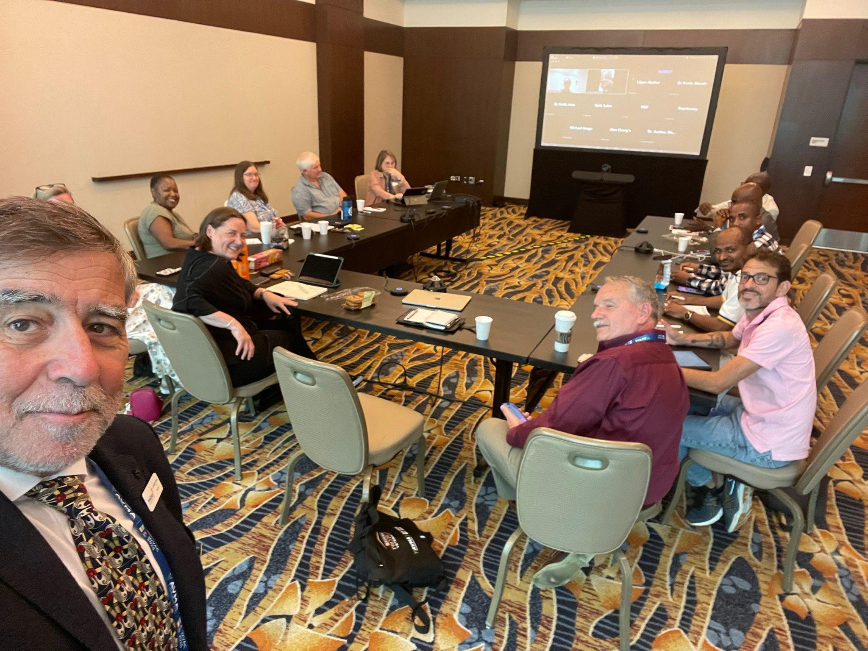
Members attending hybrid AVMA-AFSCAN meeting in the Scarlet Oak room on the Mezzanine level of the marriot Marquis Washington D.C (at 901 Massachussets on Saturday, July 19, 2025.
In person attendees
Virtually AFSCAN
Ambassadors attendees

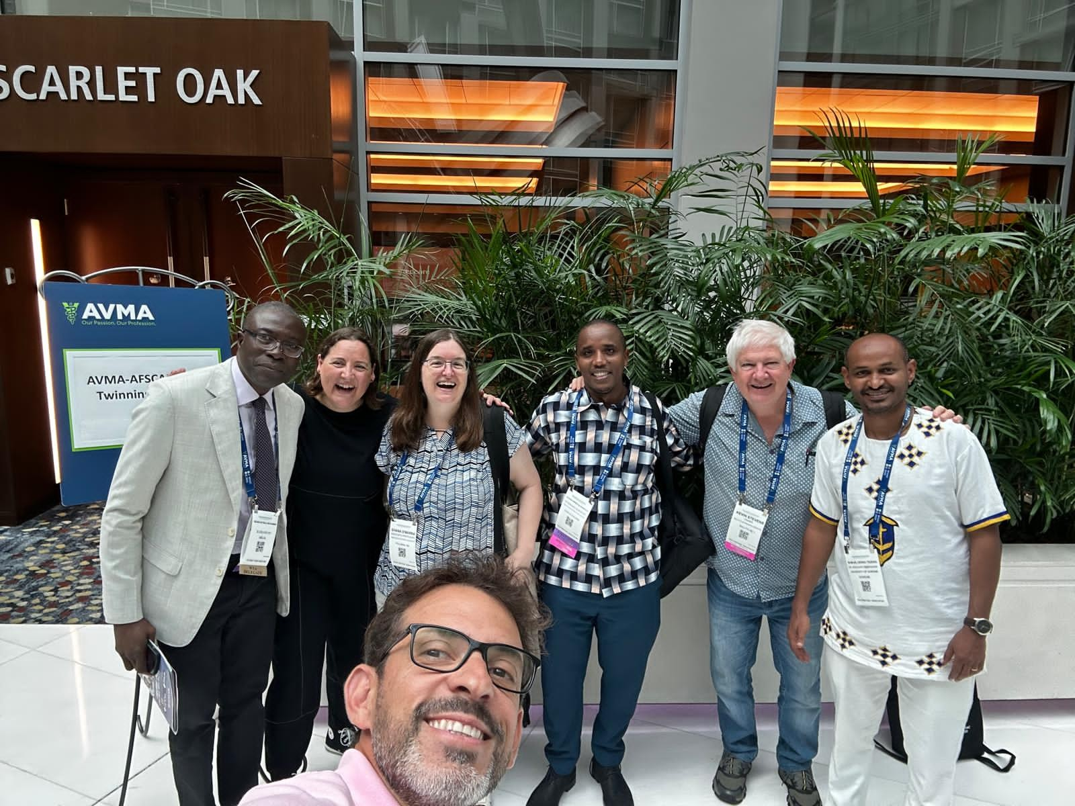
Members after AVMA-AFSCAN meeting in Scarlet Oak room on the Mezzanine level of the marriot Marquis Washington D.C (at 901 Massachussets on Saturday, July 19, 2025

Social Events

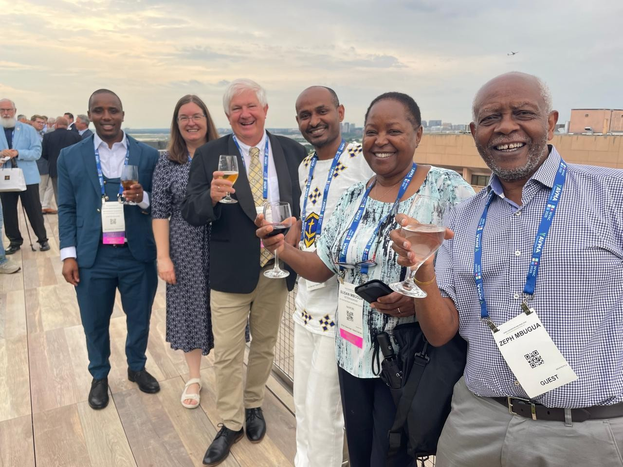
Yohana, Shana, Kevin, Samuel, Susan and Zeph Mbugua from Left to right on top roof of Spy museum during social event on Saturday, July 19, 2025.
The social events were very organized and refreshing. We visited the Spy Museum, where we were able to see Washington D.C. from the rooftop of the museum, meet veterinarians, and network.

We also attended the Gala Dinner and other AVMA -AFSCAN Dinner events.

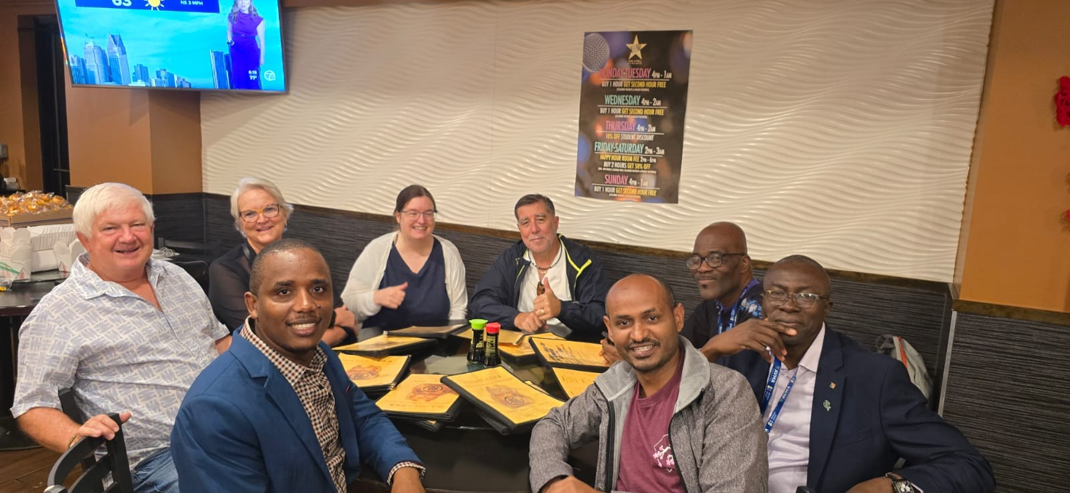
Kevin, Jelly, Shana, Gabriel, Olatunji, Bala, Samuel and Yohana during a dinner event at Surratt Boarding house, 604 H Street, N.W Washington D.C

Shana, Kevin, Gabriel, Rafael, Yohana and Jelly at Dinner event in Washington D.C

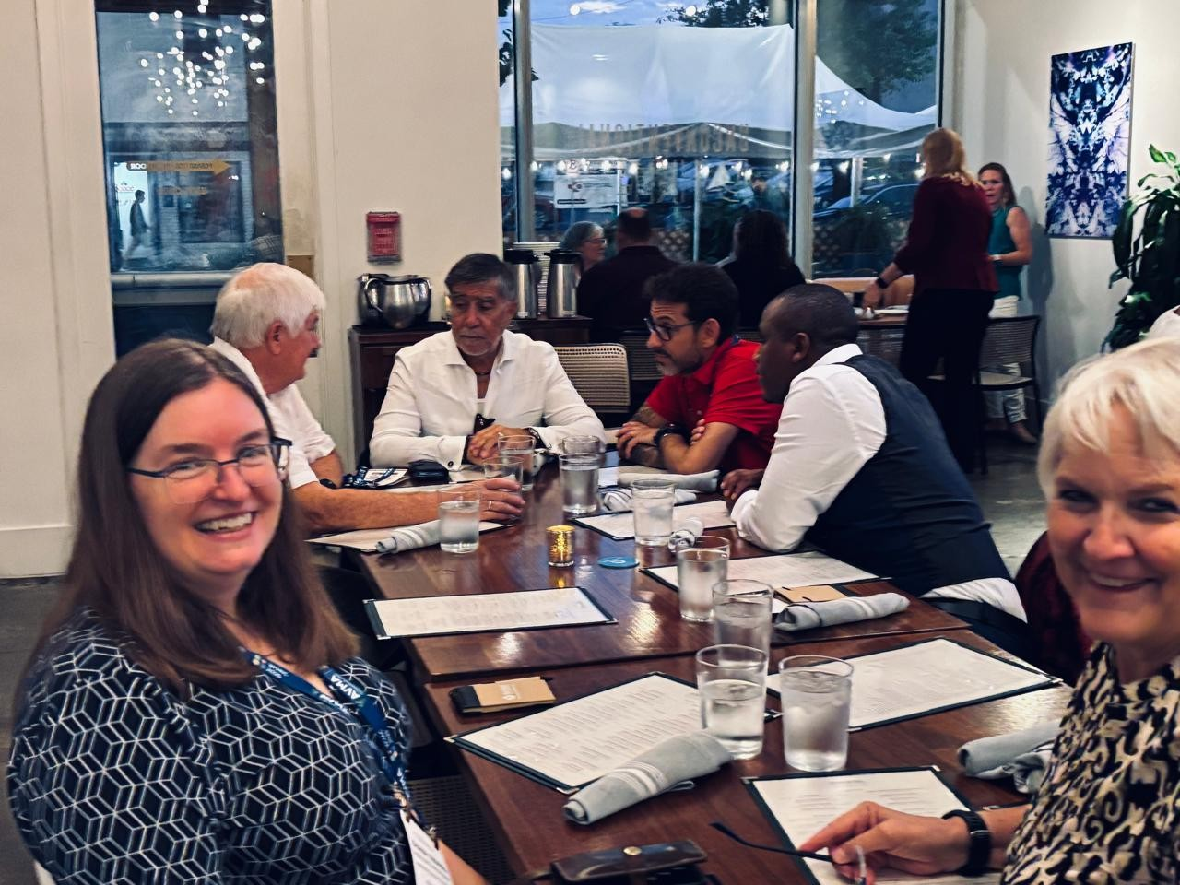

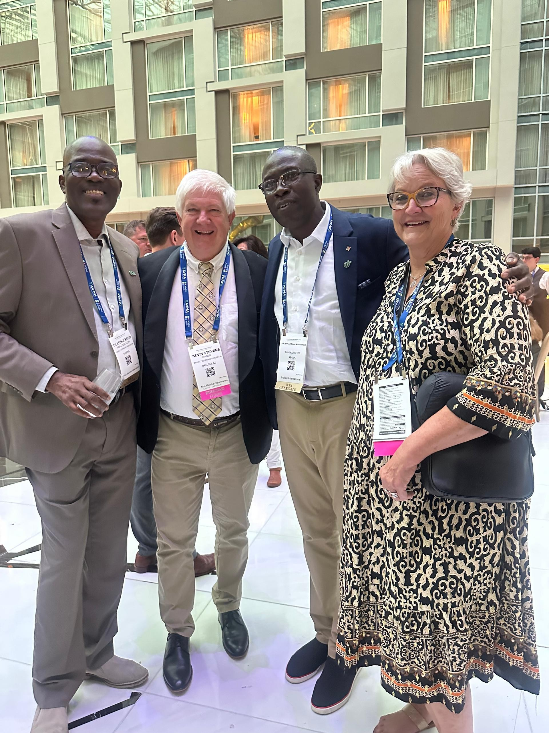

Olatunji, Kevin, Bala and Jelly during a social event in Marriot hotel Washington D.C July 21, 2025.

Future plan.
I plan to organize a knowledge-sharing session within my organization and propose integration of some clinical tools observed during the convention. Additionally, I aim to support the expansion of twinning meetings within Tanzania by onboarding new veterinarians.
ACKNOWLEDGEMENT
I extend my sincere gratitude to the AFSCAN Board, Dr. Gabriel Varga, Dr. Kevin Stevens, Dr. Michael Topper, and Dr. Berth Sabin, as well as Dr. Shana and Dr. Sonya from the AVMA, for the scholarship, their support and mentorship.
Tanzania Small Animals Veterinary Organization (TASAVO) for recommendations and support ASFCAN Ambassadors for cooperation, Samuel Derso for support ad collaborations.
Dar es Salaam Animal Clinic for Support

