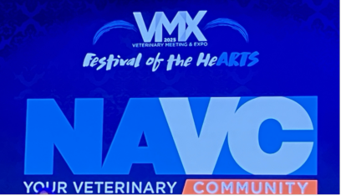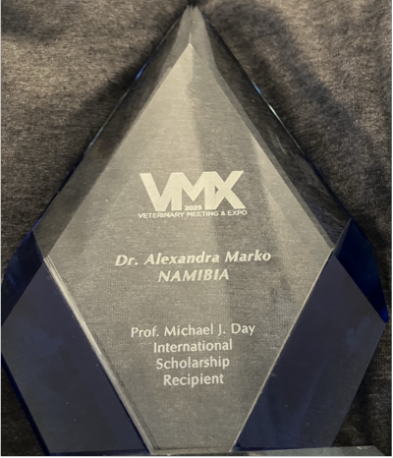

NAVC/VMX
AFSCAN Michael Day Scholarship
This was an absolutely amazing experience!
Coming from Namibia, where the biggest veterinary
conference hosts 140 delegates and 25 industry stalls, to the biggest veterinary conference with
close to 30 000 delegates and over 730 industry stalls! It was actually quite overwhelming…but in a good way.
Thank you to the North American Veterinary Community (NAVC) for your outstanding generosity in hosting me and for welcoming me and making me feel part of this community from day one.
Thank you to AFSCAN and the ProSalus Foundation for this opportunity -it was special to meet Dr Gabriel Varga there, who was the ﬁrst recipient of this International Scholarship, 32 years ago.
This long time of continued support and commitment from the NAVC speaks for itself.

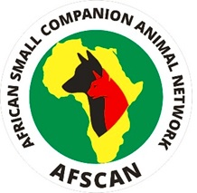
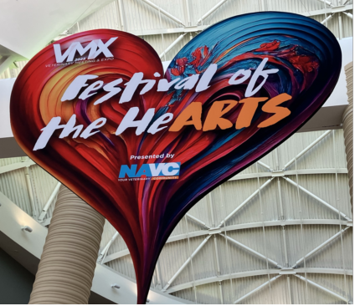



It was fascinating to see how well-organised it was, right to the tiniest detail. The decor in line with the theme “Festival of the HeArts” was really beautiful and the evening events were stunning! There was a concert with Dan and Shay, a dress-up costume party, an acrobatics performance and a talent show.
It was exciting to have Kevin Costner as keynote speaker, who at some point had more than half
of the audience in tears… The appreciation shown to all members of the veterinary team was very special. Being in this profession where so much is demanded of individuals all the time, not just
physically but also emotionally, it was an important reminder that vets and vet team members
value a kind gesture or words of thankfulness and appreciation for their work every now and again.

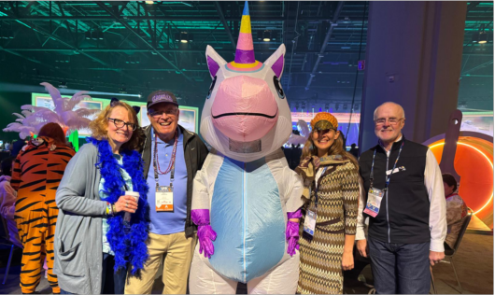

This year’s “Fun(d) Run” a 5km Colour Run was well-supported by the veterinary community, with
over 500 entries and a lot of fun! It is organised jointly by NAVC/VMX and the ProSalus Foundation, with proceeds going to the main activities of the ProSalus Foundation, such as the AFSCAN project (https://prosalusfoundation.org/our-projects/), rabies control, disaster relief support, scholarships and others.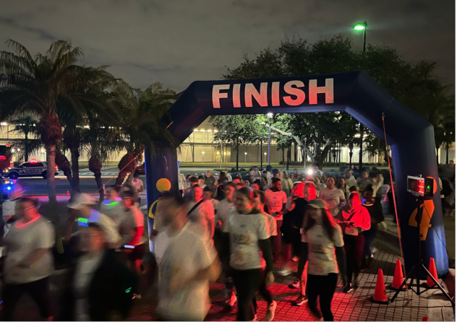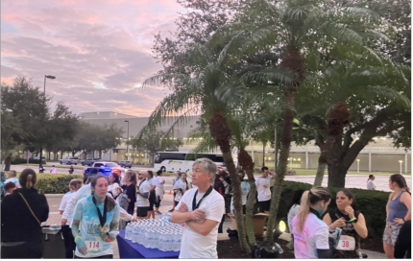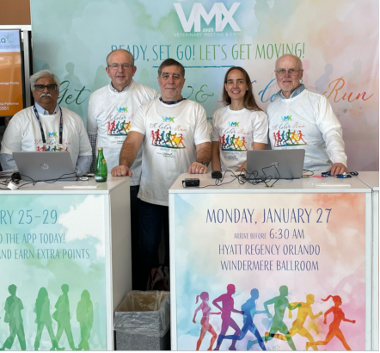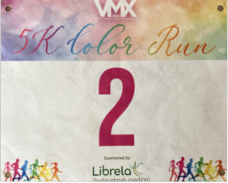

The lectures were really great -relevant topics, fantastic speakers, high-tech IT support, with an
app where lectures could be watched in real-time.
There was just so much on oﬀer that it was hard to choose, with so many simultaneous steams, covering small, large and exotic animals, practice management and personal development. With
over 1200 CE hours on oﬀer, it was mind-blowing. I love the fact that the on-demand sessions are still available on the app afterwards.
The wet-lab was very well organised and provided great practical experience with valuable insight and detailed help from the instructors.

The industry stalls in the expo hall were remarkable -very innovative ideas, designs and merchandise. The “Art District” with an art exhibition, poet and craft corner were so unique. This was really tailored to the veterinary profession: I loved the cat and puppy corners, where attendees could spend time with cats and dogs and even do puppy pilates.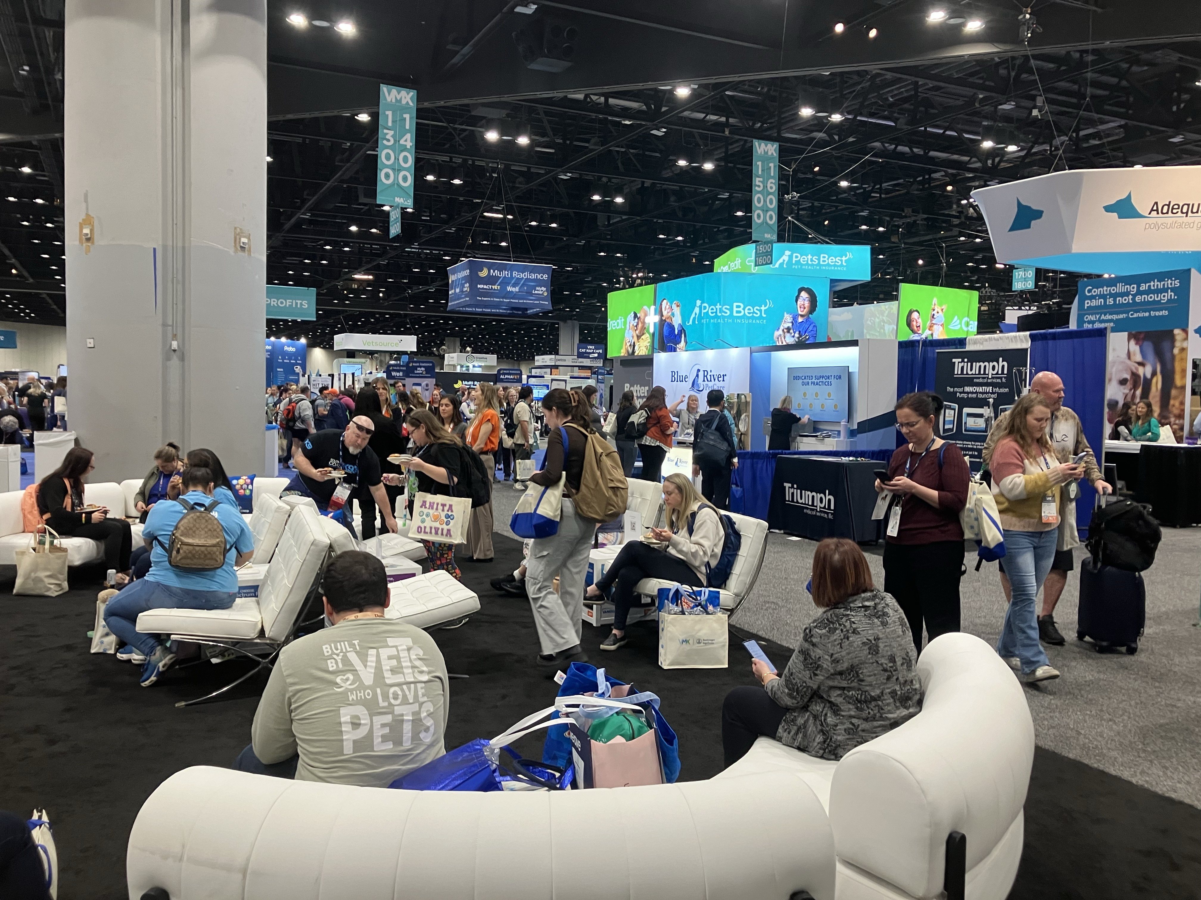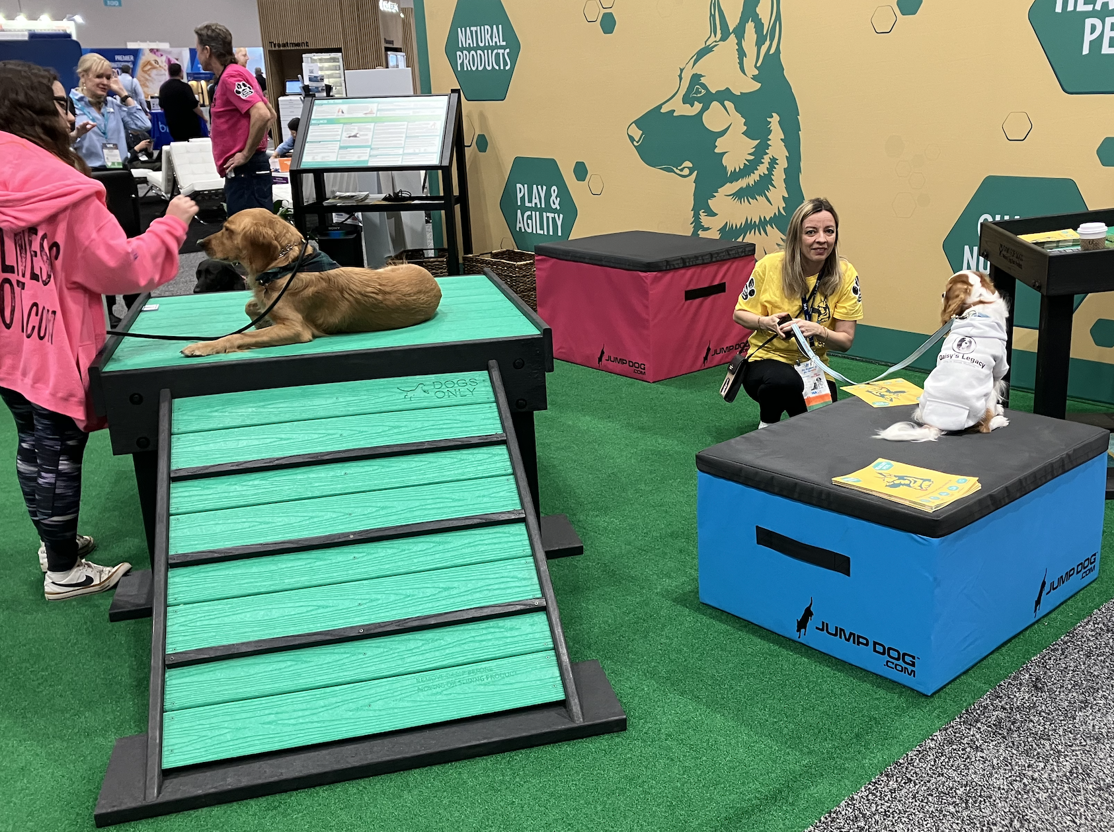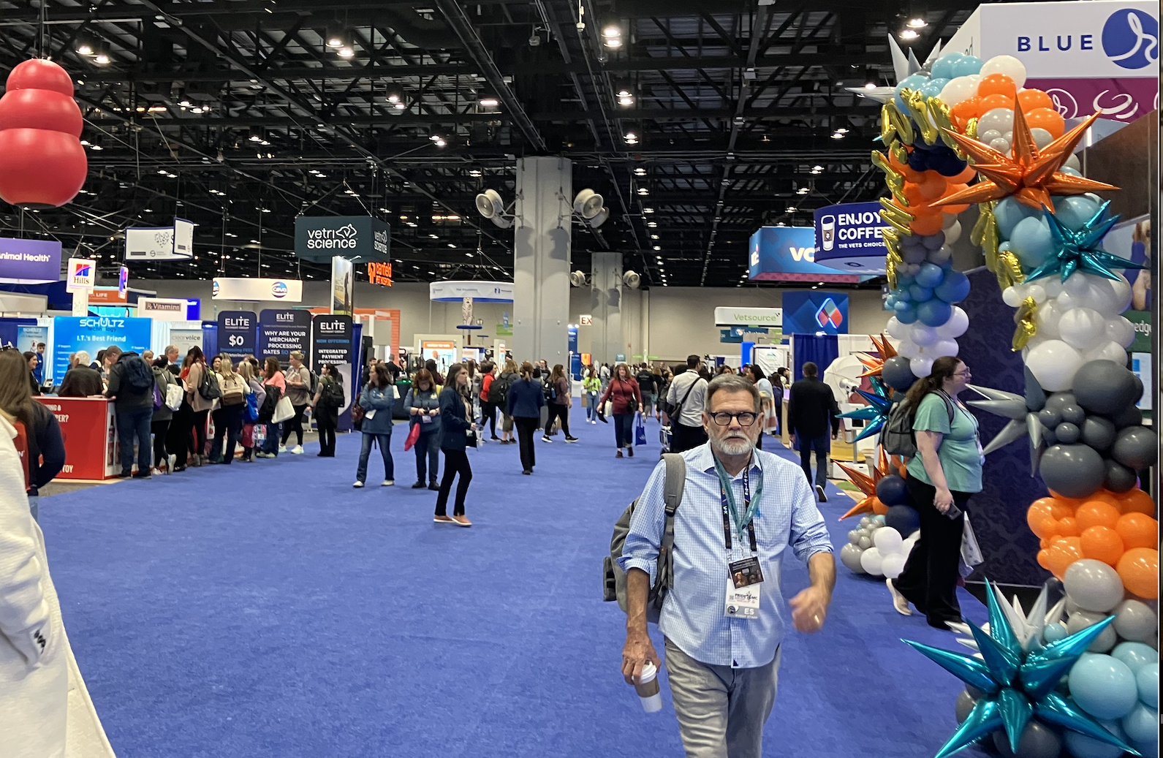

Meeting the other International Scholars, Naduni from Sri Lanka, Jhessenia from Peru and Krishna
from Kenya was a lot of fun and hopefully we’ll stay in touch. Throughout the conference, I got the chance to meet sooo many people -the networking opportunity was really great andI’mlooking
forward to hosting everyone in Namibia one day…

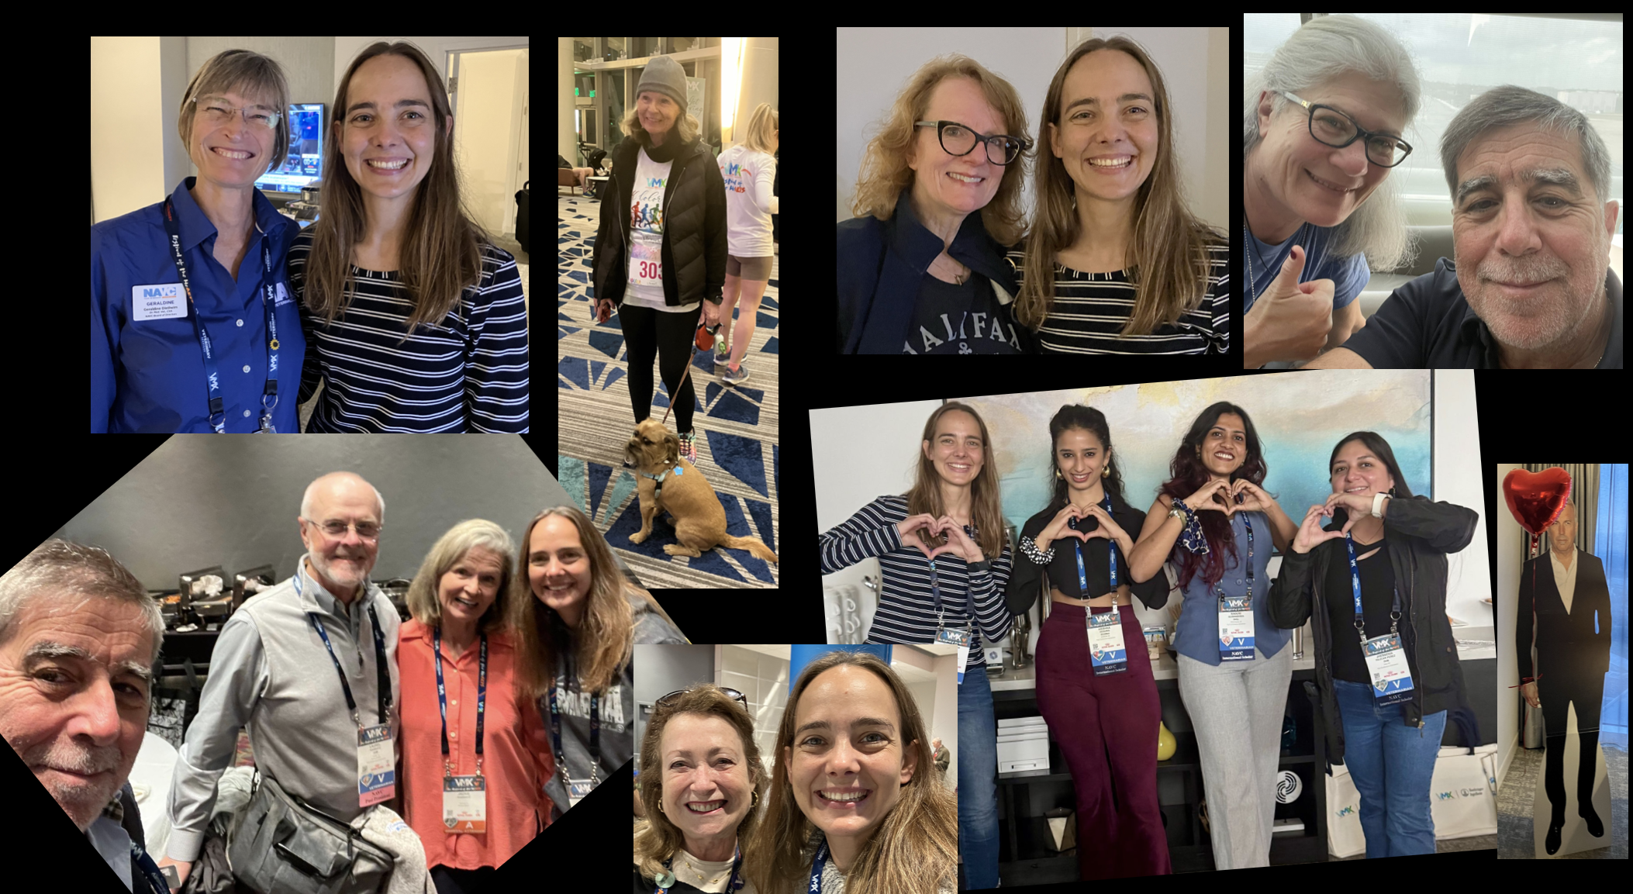

This whole experience was just such an amazing privilege and has inspired me and ﬁlled me with so many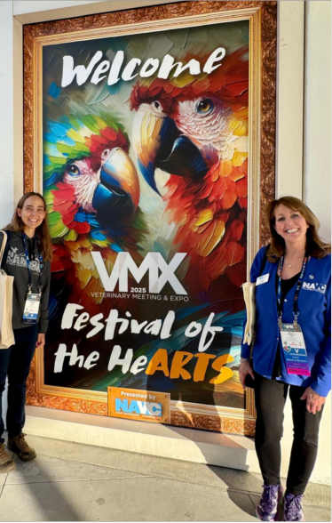
new ideas for our veterinary community back home -with home I mean “all of Africa”.
Thank you, thank you, thank you!

Alexandra Marko