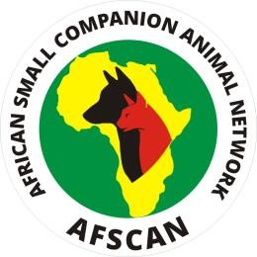
AFSCAN is a ProSalus Foundation initiative that facilitates capacity building in the African community
to enhance quality in small companion animal medicine, promoting a One-Health perspective.

The AFSCAN Research Award
This opportunity is available to individuals working at an African Veterinary School or private practice in an AFSCAN-participating country [Angola, Burundi, Ethiopia, Ghana, Kenya, Namibia, Nigeria, Tanzania, Uganda and Zambia]. It allows them to apply for a grant to fund a clinical research project of their design. Applicants must be active members of their National Association. The project should address a specific question related to the disease or welfare of companion animals in Africa, preferably from a One Health perspective. The research will be conducted in veterinary schools and/or private practice laboratories. Through this initiative, AFSCAN aims to foster collaboration with research laboratories outside Africa working in a similar field. Applicants are invited to propose partner laboratories as part of the application process.
In 2026, AFSCAN offers funding of up to US$10,000 per successful project.
All applications will undergo a formal peer-review process by the AFSCAN Scientific Committee. Potential projects will be reviewed for scientific novelty, validity, ethical basis, and their relevance to the African context. The AFSCAN Board will make the final decision.
Each application must be submitted with a letter of endorsement from the Head of the Department (for applicants working at Veterinary Schools) or the Chief of the Laboratory (for applicants working at private practices). Additionally, applicants must provide a letter of support from a Small Animal National Association Board Member and a letter of support from the respective AFSCAN Ambassador (see below).
If a granted project remains unpublished or is not presented at a conference within two years of submitting the final report, or if the project remains unfinished, the country may be disqualified from applying for future grants for three years. However, the country may be precluded from seeking additional grants if the situation occurs again.
All projects must be submitted to the respective country Ambassador by June 30th for an initial review. During this phase, the Ambassador will verify if the forms are correctly completed, with the necessary signatures and all required documents attached. After this initial evaluation by the Ambassadors, the projects should be submitted by e-mail to Prof. Mary Marcondes (marcondes.mary@gmail.com), with the message's subject line ‘AFSCAN Research Proposal and a letter from the Ambassador confirming that the project has been reviewed. Submissions must be sent before September 30th. The final review and decision process will take approximately three months, after which successful applicants will be notified.

